LKSN 2019
Graphic Design
Technology

Test Project Module 5
Packaging Design

Submitted by : Ganjar Satrio, Budi Sriherlambang, Darma

CONTENTS
This Test Project contains the following documentation/files:
LKSN2019_GDT_Modul 5 Package Design_Text
LKSN2019_GDT_Modul 5 Package Design_Recycle Logo
LKSN2019_GDT_Modul 5 Package Design_QR code
LKSN2019_GDT_Modul 5 Package Design_Images
LKSN2019_GDT_Modul 5 Package Design_Logo

INTRODUCTION
Space Colony Building
The world space exploration competition is increasingly fierce. It was marked by the presence of several rocket and satellite launches that were successfully carried out by various countries in the world, including India, China and the United States.
Facing this condition, the National Aeronautics and Space Agency of Indonesia (LAPAN) felt the need to respond with the development of space exploration for Indonesia. In collaboration with the Army Industry (PINDAD), the first Indonesian space colony building is being designed.
The colony building will have several functions, including as a residence, a base for transit of space travel, a center for biological research and the study of mineral stones contained in planets that are explored.
To provide education about this plan, “Lumment” a domestic-made lighting product creates an interactive paper-based educational package for children. A paper structure design will be made on a paper which if it is assembled, will form a colony building with the lamp product inside it.
DESCRIPTION OF PROJECT AND TASKS
You are ordered to make display packaging designs that are attractive and easily assembled by children aged 7-13 years old.
Project:
- Task 1: Create logo for “Lumment”
- Task 2: Design a creative display packaging

Target group:
Children aged 7-13 years old who interest in science and future technology

INSTRUCTIONS TO THE COMPETITOR

- Create a folder on your Desktop called YY_MOD5 (where YY represents the number of your workstation).
- This folder must include the following 2 subfolders:
- A folder named “Final”: it should contain all of the final files in subfolders Task 1 and Task 2 with PDF, ICC profile, native files, fonts and linked images.
- A folder named “Original”: it should contain other files that are not final files used for creating your design.
- The color mode of your images will be evaluated in the PDF files.
- The final resolution and file formats will be assessed in your working software, such as Illustrator or InDesign.
- The JPG file format is NOT ACCEPTED for images; only the following file formats are acceptable .TIF / .EPS / .AI / .PSD / DSC 2.0
- Task 1 must be created in Illustrator; Task 2 the final must be in Illustrator;
- You must use ALL of the text provided for each task as specified.
- You must use ALL of the images specified as per the tasks.
Time limit for this test project
The Test Project must be completed in 4 hours

TASK 1: Create a logo for Lumment
Target audience:
People who interest in science and future technology
Concept:
Future Technology

Requirements for logo:
- The logo should be in vector.
- The logo must have the word: Lumment
- The logo must combination mark (logotype & logogram)
- You must create at least 1 more vector element.
- The logo should NOT include any gradients.

Technical specifications:
Text : All text must be converted to outlines.
File Types : Illustrator (Working File)
: PDF/X-4:2010 (Final File)
Trapping : 0.30 pt. (if needed)
Colors : CMYK
Naming : Folder Logo CMYK
File YY_MOD5_Logo_CMYK.ai
YY_MOD5_Logo_CMYK.pdf

You must deliver :
Folders as specified in “Instructions to the Competitor”
Only files from these folders will be assessed.
- 1 Illustrator file ( .ai)
- 1 PDF files. (PDF/X-4:2010)

TASK 2: Creative Display Package
Design a creative display package of Lumment - Space Colony Building

Technical specifications:
Max Dimensions of gift package : 297 mm x 420 mm (A3 flat)
Dimensions of qr code : 35 mm x 26 mm
Bleed for dieline (if necessary) : 3 mm
Protrude : 20% product outside the package
Colors : CMYK + Cut, Fold lines and Glue
spot color must be overprint
ICC Profile : Coated GRACol 2006
(ISO 12647-2:2004)
Ink density : 350%
Trapping (if necessary) : 0.4 pt
Grayscale and Color image Resolution : 280 – 300 ppi 100%
Bitmap image Resolution : 600 – 1200 ppi 100%
Naming : YY_MOD5_Packaging.ai
YY_MOD5_Packaging.pdf

A child between the ages of 7 – 13 must be able to assemble the tasks without assistance. You must add arrows, numbers or other signs to explain the assembly of both tasks on the CUT layer. The instructions must be on the CUT spot color on the CUT layer. Include icons or illustrations for the CUT, FOLD & GLUE instructions. No text must be included.

Example:
      

CUT lines : Spot colour, stroke weight 1pt on
separate CUT layer in Illustrator and pdf.
Name colour and layer: CUT LINES.


* sample showing cut lines on coloured background. You may choose any spot colour that will have enough contrast to your background colour

FOLD lines : Spot colour 0.5pt dashed line.
on separate layer in Illustrator and pdf.
Name of colour and layer : FOLD LINES


* sample showing dashed fold line on colour background. You may choose any PMS colour that will have enough contrast to your background colour

GLUE Area : Indicate glue points with a circle —
Spot colour 0.5pt stroke only, no fill colour.
Name the colour and layer : GLUE AREA

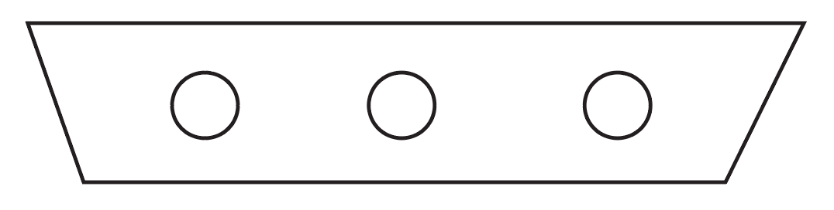

Requirements for Package:
These elements (LKSN2019_GDT_Modul 5 Package Design_Text) from appendix must be included in your package design.

- Include CMYK brand logo from Task 1
- Include LAPAN & PINDAD Logo (LKSN2019_GDT_Modul 5 Package Design_Logo)
- Include qr code: the size needed is width 35 mm x height 26 mm and
must be 100% K (LKSN2019_GDT_Modul 5 Package Design_QR code)
- You may create your own illustrations for the package design to represent Space Colony Building
- Essential Package Symbol to be included in Vector-Format only: Recycle (LKSN2019_GDT_Modul 5 Package Design_Recycle Logo)
- Colours specifications

You must deliver:
Folders as specified in “Instructions to the Competitor”. Only files from these folders will be
assessed.
- 1 Illustrator file ( .ai)
- 1 final composite PDF (PDF/X-4:2010) file including Cut, Fold lines and Glue area on one separate layer, bleed, color bars and registration marks only.
- 1 printout trimmed at 100%
- 1 final 3D mock-up

